E-LEARNING WEBSITE

**A PROJECT REPORT**

## Submitted by

**Sumit Anand (21BCS11540) Vishal Singh (21BCS2439) Sumit Saini (21BCS11504) Sanjana Rathore (21BCS11612)**

**Muktanshi Sharma (21BCS11545)**

## In partial fulfillment for the award of the degree of

**Bachelor of Engineering**

#### IN

### Computer Science and Engineering



#### Chandigarh University

#### May 2023

**BONAFIDE CERTIFICATE**

Certified that this project report **“E-learning w”** is the bonafide work of **“Sumit Anand**

**(21BCS11540), Vishal Singh(21BCS2439), Sumit Saini(21BCS11540), Sanjana Rathore (21BCS11612), Muktanshi Sharma(21BCS11545)”** who carried out the project work under my/our supervision.

##### Signature of HOD Signature of Supervisor

##### Dr. Ajay Kumar Singh Ms. Meena Pundir

##### Head of the Department Assistant Professor, CSE

#### Computer Science and Engineering Computer Science and Engineering

##### Submitted for the project viva-voce examination held on

#### INTERNAL EXAMINER EXTERNAL EXAMINER

**ACKNOWLEDGEMENT**

### We would like to express our special thanks of gratitude to my project guide “Ms. Meena Pundir”, as well as our HOD“Dr. Ajay Kumar Singh”who gave us the golden opportunity to do this wonderful project on E-Learning, which also helped us in

### doing a lot of research and we came to know about so many new things, we are

### really thankful to them.

### In addition to this, we would also like to thank our parents and friends who helped us a lot in finalizing this project within the limited time frame.

|  |  |
| --- | --- |
| Date : |  |
| Place : Gharuan Mohali Punjab | Sumit Anand (21BCS11540) |
|  | Vishal Singh (21BCS2439) |
|  | Sumit Saini (21BCS11504) |
|  | Sanjana Rathore (21BCS11612) |
|  | Muktanshi Sharma (21BCS11545) |

**TABLE OF CONTENTS**

CHAPTER 1. INTRODUCTION 1

* 1. Identification of Client/ Need/ Relevant Contemporary issue 1
  2. Identification of Problem 2
  3. Identification of Tasks 3
  4. Timeline 4
  5. Organization of the Report 5

CHAPTER 2. LITERATURE REVIEW 7

* 1. Timeline of the reported problem
  2. Existing solutions
  3. Bibliometric analysis
  4. Review summary
  5. Problem definition
  6. Goals/Objective

**CHAPTER 3. DESIGN FLOW/PROCESS**

### Evaluation & Selection Specification/Features………………………….

### Design constraints

### Analysis of features and finalization subject to constraints…….

### Design flow ……..

### Design selection………

### Implementation plan/methodology

**CHAPTER 4. RESULTS ANALYSIS AND VALIDATION**

### 4.1. Implementation of solution

**CHAPTER 5. CONCLUSION AND FUTURE WORK**

### Conclusion

### Future scope

**References**

**List of Figures**

###### Figure 1.1 4

###### Figure 3.1… 25

###### Figure 3.2… 26

###### Figure 4.1… 32

###### Figure 4.2… 32

**ABSTRACT**

The e-learning website is a platform that provides a virtual learning environment for users to access a variety of educational materials and courses. It utilizes technology to facilitate the learning process, enabling users to learn at their own pace and from anywhere in the world.

The website offers an extensive selection of courses covering various subjects and difficulty levels, ranging from beginner to advanced. To enhance user engagement and promote effective learning, the platform incorporates interactive features such as quizzes, games, and videos. These elements help to make the learning experience more dynamic and engaging.

Additionally, the e-learning website provides personalized learning experiences by offering tailored recommendations based on users' learning preferences and progress. This personalized approach ensures that users receive content and courses that align with their individual needs and goals.

The platform is designed with a user-friendly interface that is intuitive and easy to navigate. Users can easily track their progress, earn certificates of completion, and receive feedback on their performance. These features help users stay motivated and monitor their achievements throughout their learning journey.

Overall, the e-learning website serves as a valuable resource for individuals looking to acquire new skills and knowledge, further their education, or improve their career prospects. Its convenient accessibility, interactive features, and personalized learning approach make it a valuable tool for learners of all backgrounds and levels of expertise..

**CHAPTER 1.**

**INTRODUCTION**

# Identification of Client / Need / Relevant Contemporary issue

* + - Identification of clients in an e-learning website plays an important role for ensuring security, personal details, and to track the user’s progress.
    - The most common way for identification of users is enabling the users to set username and password. By this method user can log in to the website to avail their required courses.
    - Users can also connect to the learning websites by using their social media accounts like Facebook, Twitter, or Google. These are all the registration process for identification of the users. One can be easily identified after the registration of the users to the website. It is important to choose a secure and reliable identification methods to protect the user’s data.
    - E-learning websites are online platforms that provides educational content and courses to learners through the internet. This website is useful for learners as it offers a flexible and convenient way to learn new skills or gain knowledge.

Students can take advantage of E-learning websites as it provides a range of multimedia resources, such as video lectures, audio recordings, quizzes, assignments, worksheets, and other materials.

* + - All these resources are available for learners at a very affordable price.
    - Some courses are also having free enrollments. Students can interact with the teachers on the camera for clearing their doubts.
    - Learners get the chance to uplift or raise their skills and gain knowledge apart from the offline education.
    - There is also a great benefits for group discussion among the learners as the website is providing a global reach to connect with other learners.

**1**

* + - One of the most beneficial features of this learning platform is students can choose the Course and content that are most feasible or relevant to their interests and needs.

Overall, e-learning websites are a valuable resource for learners to gain knowledge and learn a good skill for their development. There is a wide range of contemporary or key issues in the E-Learning website that impacts the Educators, learners and the institutions that are providing the courses.

* + - Online security is one of them, as the website is containing very sensitive or important information about the users, there is a constant threat of Cyber Attacks, hacking, and data breaches.
    - To gain the trust of the users a very high confidential security should be provided.
    - The learning websites must ensure that the content provided to the users should be of high quality and easily accessible.

# Identification of problem

There are a number of issues with both traditional classroom instruction and modern e- learning platforms. Here are a few of the most typical offline Learning(1)

. **Limited accessibility**: Not all students have access to quality education due to geographical barriers or lack of resources.

* + - **Fixed schedule**: Students have to attend classes at specific times, which may not be convenient for all learners.
    - **Inflexibility**: Traditional education systems follow a rigid structure, leaving little room for students to pursue their interests or passions.
    - **Lack of individual attention**: In a traditional classroom setting, teachers may not be able to give each student the individual attention they need.

**2**

E-Learning Websites:

* + - **Lack of motivation**: Online courses can be less motivating for students since they lack
    - **Technical difficulties**: Technical glitches and poor internet connectivity can cause frustration and disrupt the learning experience.
    - **Limited social interaction**: Online learning may not provide the same opportunities for social interaction and networking that traditional classrooms do.
    - **Quality control**: With the increasing number of e-learning websites, it can be difficult to distinguish between high-quality and low-quality courses.
    - **Inability to address individual needs**: Online courses may not be tailored to address individual learning needs, which can result in students struggling to understand certain concepts.

# Identification of Tasks

Identifying the tasks for an e-learning website will depend on the specific goals and objectives of the website, as well as the target audience. However, some common tasks that could be considered for an e-learning website are:

* + - **Course search and selection**: Users should be able to quickly explore and search for courses that interest them, apply filters based on level or category, and view comprehensive course descriptions.
    - **Course enrollment:** Users should be able to register for a course, pay for it (if necessary), and receive confirmation of their enrollment.
    - **Learning management**: The website should provide a platform for users to access the course materials, including video lectures, assignments, quizzes, and other learning resources. This platform should also allow users to track their progress and communicate with the instructor or other students.
    - **Assessment and feedback**: The website should provide tools for instructors to create and administer assessments, such as quizzes or exams, and provide feedback to students on their performance

**3**

* + - **Certification and credentialing**: The website should offer certificates or other credentials to users who successfully complete a course or program.
    - **Community building**: The website should facilitate communication and collaboration between students, instructors, and other stakeholders, through features such as discussion forums, social media integration, or networking events.
    - **Technical support**: The website should provide user-friendly technical support to ensure that users can access and use the platform without any issues.

# Timeline:

The timeline provides a brief overview of the website’s development over the course of several years, highlighting key milestones and events that contributed to its growth and success. A timeline can help users understand the website’s history and evolution, and can be valuable tool for marketing and promoting the website to new users. Timeline for E-learning website:

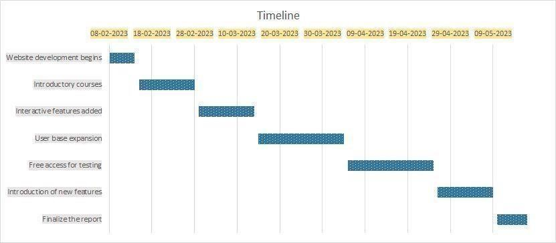

###### Fig 1.1

**4**

Week 1 (February 8-14):

* + - E-learning website development begins, with a focus on creating a user-friendly platform that offers a wide range of educational content.

Week 2-3 (February 8-14):

* + - The website’s first courses are launched, including introductory courses on a variety of topics and more advanced courses for users with more experience.

Week 4-5 (March 1-14):

* + - The website’s first interactive features are added, including quizzes, polls, and discussion forums.

Week 6-8 (March 15-April 4)

* + - The website’s user base expands significantly, with thousands of new users signing up each month.

Week 9-11 (April 5-25):

* + - In response to COVID-19 pandemic, the website offers free access to all of its courses to support students and educators for learning.

Week 12-13 (April 26 - May 9):

* + - The website introduces new features to improve accessibility, including closed captioning for videos and audio descriptions for images.

Week 14 (May 10 – 17):

* + - The website’s course library expands to include more specialized content in areas like data science, artificial intelligence, and digital marketing

**5**

* + - April 2023: The website partners with several universities to offer accredited courses that can be used towards degree programs.

# Organization of the Report

When writing a report about an e-learning website, it's important to organize our content in a way that is clear, concise, and easy to follow. Here is one possible structure for organizing a report about an e-learning website:

* + - **Chapter 1**: Introduction

Start with an overview of the website and its purpose, as well as any relevant background information or context. Introduce the main goals and objectives of the report, and provide an outline of the key areas that will be covered.

* + - **Chapter 2**: Literature Review

This literature review seeks to explore the different studies that have been conducted on E- learning websites and aims to explore studies on online platforms.

* + - **Chapter 3**:Design Flow

This chapter presents a design flow for an e-learning website. Designing an e-learning website requires a thorough understanding of the users, their needs, and the learning content.

* + - **Chapter 4**: Result Analysis

This chapter describes the analysis of the result after taking the courses on E-learning website. By analysis, we can gain valuable insights into the effectiveness of E-learning website and make a effective decisions about how to improve it.

* + - **Chapter 5**: Conclusion and future work

The conclusion is to provide an effective resources to the learners and the future work is to make more and more engagement of the learner

**6**

**CHAPTER 2.**

**LITERATURE REVIEW**

* 1. **Timeline of the reported problem**

**1990 2010**

|  |  |  |  |  |
| --- | --- | --- | --- | --- |
| **A** | With the advent of  the internet, e- **C**  learning emerged as a concept, and early  e-learning websites started to appear.  However, literature  reviews in this field were scarce. | | The proliferation of e- learning websites and online education platforms led to an explosion of literature on the subject.  Literature reviews began to explore topics such as student engagement, retention, and motivation. |  |
|  | **2000**  **B** | As e-learning became more popular, literature reviews started to become more common in this field. The focus was on identifying the most effective E-learning methods and  tools. | **2020**  **D** | The COVID-19  pandemic led to a massive shift toward online learning, which in turn spurred a surge of interest in literature reviews on e- learning. |

**7**

**2.2 Existing solutions**

There are many existing solutions in e-learning websites that have been developed to enhance the learning experience for students. Here are some examples:

* An LMS is a software application that provides a platform for delivering and managing online learning. LMSs offer a range of features such as course management, assessments, and tracking of student progress.
* Video-based learning has become increasingly popular as a way to deliver engaging and interactive content. E-learning websites can include pre-recorded lectures, live webinars, or interactive videos that allow students to pause, rewind, and review content at their own pace.
* The techniques such as badges, rewards, and leaderboards can increase student engagement and motivation. E-learning websites can incorporate these techniques to create a sense of competition and achievement among students.
* Adaptive learning systems use data analytics to personalize the learning experience for each student. These systems adapt to the student's learning style, progress, and performance to provide tailored content and assessments.
* E-learning websites can incorporate social features such as discussion forums, group projects, and peer review assignments to foster a collaborative learning environment.
* Many e-learning websites offer mobile apps that allow students to access course materials and complete assignments on their mobile devices. This makes learning more flexible and accessible for students who are on the go.
* Virtual and augmented reality technologies can provide an immersive and engaging learning experiences that help students retain information. E-learning websites can incorporate these technologies to create simulations and interactive experiences.
* Analytics software can be used to track student progress and engagement. It can provide insights into how students are interacting with course materials and identify areas where they may need additional support.
* AI tools can be used to provide personalized learning experiences. For example, an AI-powered Chat Bot can provide real-time support to students, while an adaptive learning algorithm can adjust course materials based on each student's progress.

**8**

Online learning platforms can incorporate video conferencing solutions that allow instructors and students to interact in real-time.

There are several existing solutions available for creating e-learning websites, each with its own set of features and benefits. Here are some popular options:

Moodle: Moodle is a widely used open-source learning management system (LMS) that allows you to create and manage online courses. It offers a range of features, including content creation tools, assessment management, progress tracking, discussion forums, and communication tools. Moodle is highly customizable, flexible, and suitable for both educational institutions and corporate training programs. Being open-source, it also benefits from a large community of developers and users who contribute to its ongoing development and support.

Blackboard Learn: Blackboard Learn is a comprehensive LMS that provides a robust set of tools for creating, delivering, and managing online courses. It offers features such as content creation, assessment management, grade tracking, discussion forums, and multimedia integration. Blackboard Learn is widely adopted by educational institutions and provides extensive administrative capabilities, making it suitable for large-scale implementations.

Canvas: Canvas is a cloud-based LMS known for its user-friendly interface and flexibility. It offers a variety of features, including content creation, assignment management, grading, communication tools, and collaboration features. Canvas provides a modern and intuitive design, making it easy for instructors and learners to navigate and interact with the platform. It also integrates well with other educational technologies and supports both educational institutions and corporate training programs.

Learn Dash: Learn Dash is a popular Word Press plugin that enables you to transform your Word Press website into a full-featured LMS. It provides tools for creating and managing online courses, including content dripping, quizzes and assessments, certificates, progress tracking, and integration with popular payment gateways. Learn Dash is highly customizable and integrates seamlessly with the vast ecosystem of Word Press plugins and themes.

**9**

TalentLMS: TalentLMS is a cloud-based LMS suitable for businesses of all sizes. It offers a user friendly interface, mobile support, and a range of features for course creation, assessment management, progress tracking, and reporting.

Teachable is a platform created exclusively for developing and marketing online courses.. It provides an intuitive interface that allows instructors to create multimedia-rich course content, set up payment gateways, track student progress, and communicate with learners. Teachable offers marketing and sales tools to help instructors promote and sell their courses effectively. It is particularly suitable for individual course creators and entrepreneurs who want to monetize their expertise through online education.

Coursera for Business: Coursera for Business is a platform that offers a curated selection of online courses from top universities and institutions. It is designed for organizations looking to provide professional development and training to their employees. Coursera for Business offers a wide range of courses in various domains, allowing organizations to create customized learning paths for their employees. It also provides analytics and reporting features to track the progress and performance of learners.

When choosing an e-learning solution, it's important to consider factors such as the specific needs and goals of your organization or educational institution, the level of customization required, integration capabilities, scalability, and budget constraints. Evaluating these factors will help you determine which existing solution aligns best with your requirements and provides the features and support necessary for a successful e-learning website.

Overall, there are many existing solutions in e-learning websites that can enhance the learning experience for students. The key is to choose the right solution for the specific learning needs of each student and to ensure that the solution is accessible and engaging.

**10**

**2.2 Bibliometric analysis**

Bibliometric analysis in e-learning websites involves analyzing academic literature and research articles related to the topic. It is a quantitative method of analysis that examines the patterns, trends, and relationships within a body of literature. Here are some steps involved in conducting a bibliometric analysis of e-learning websites:

* The first step in conducting a bibliometric analysis is to define the research question or objective. This will guide the selection of the literature and the analysis of the data.
* The next step is to identify relevant literature related to e-learning websites. This can be done through online databases, search engines, and other academic resources.
* Once the relevant literature has been identified, data can be collected from each article. This can include information such as author, publication year, journal or conference name, and keywords.
* The collected data can be analyzed using various bibliometric techniques such as co-citation analysis, bibliographic coupling, and citation network analysis. These techniques can help to identify key authors, journals, and research topics in the field of e-learning websites.
* The final step is to draw conclusions based on the analysis of the data. This can include identifying trends, gaps in the literature, and areas for further research.

Bibliometric analysis can help to identify the most influential authors and publications in a particular field of research. This can be useful for researchers looking to collaborate with experts in their field and can be used to evaluate the impact of a particular research article or a researcher's body of work. This can be done by analyzing citation data and other metrics.

It is a quantitative method used to assess and analyze the scholarly literature in a particular field. In the case of e-learning, bibliometric analysis provides insights into the trends, patterns, and impact of research conducted in the field. Here is a summary of the key findings from a bibliometric analysis of E-learning research:

Growth of E-learning Research: E-learning has seen a significant increase in research activity over the years. The number of publications and citations related to e-learning has been consistently growing, indicating the rising interest and importance of this field.

**11**

Research Output: Bibliometric analysis reveals that e-learning research spans various disciplines, Including education, technology, psychology, and computer science. Researchers from different countries and institutions contribute to the body of knowledge in e-learning, demonstrating its global significance.

Collaboration Networks: Collaborative research is prevalent in the field of e-learning. Co-authorship analysis reveals networks of researchers and institutions collaborating on e-learning research projects. These collaborations foster knowledge exchange, interdisciplinary perspectives, and the sharing of resources and expertise.

Highly Cited Papers: Certain papers in e-learning have received significant attention and citations within the academic community. These highly cited papers often contribute ground breaking concepts, innovative methodologies, or influential frameworks to the field. Identifying these influential papers helps researchers stay updated with the seminal works in e-learning.

Research Themes and Topics: Bibliometric analysis helps identify the prominent themes and topics within e-learning research. This may include areas such as learning analytics, mobile learning, online instructional design, virtual reality in education, gamification, and social learning. Tracking these themes over time provides insights into the evolution and emerging trends in e-learning research.

Journals and Conferences: Bibliometric analysis allows for the identification of key journals and conferences that publish e-learning research. These venues serve as platforms for researchers to disseminate their findings, share knowledge, and engage in scholarly discussions. Researchers can use this information to identify reputable outlets for publishing their own work and staying updated with the latest research in e-learning.(4)

Impact and Citations: Bibliometric analysis provides an understanding of the impact of e-learning research through citation analysis. By analyzing the citation patterns of e-learning publications, researchers can identify influential works and measure their impact on subsequent research and practice.

**12**

This information helps researchers and practitioners assess the reach and significance of specific research findings.

Research Gaps and Future Directions: Bibliometric analysis can uncover research gaps and suggest potential areas for future investigation in e-learning. By identifying underexplored topics or emerging trends, researchers can focus their efforts on addressing the gaps in the existing body of knowledge and contributing to the advancement of e-learning research

Overall, this analysis is a powerful tool that can be used to gain insights into the research landscape of a particular field. By analyzing publication and citation data, researchers can identify key authors and publications, map research topics, and identify emerging trends.

* 1. **Review summary**

The efficiency of e-learning websites is influenced by a number of important criteria, according to the literature that is currently available. These consist of:

* User-centered design: E-learning websites should be designed with the user in mind, with clear and intuitive navigation and easy access to course materials.
* Interactivity and engagement: E-learning websites should incorporate interactive and engaging elements such as quizzes, games, and simulations to enhance the learning experience.
* Personalization: E-learning websites can be made more effective by offering personalized learning paths, assessments, and content based on the learner's individual needs and preferences.
* Social learning: E-learning websites should incorporate social features such as discussion forums, group projects, and peer review assignments to foster a collaborative learning environment.
* Mobile accessibility: E-learning websites should be designed to be accessible on mobile devices to allow for learning on the go.

**13**

.

* Technical support: E-learning websites should offer technical support to learners to ensure that they can access the materials and complete assignments without technical difficulties.

One of the primary benefits of e-learning is its flexibility and convenience. With e-learning, learners have the freedom to access educational resources and courses at their own pace, anytime and anywhere.

This flexibility is especially valuable for individuals with busy schedules, allowing them to balance their education with work, family, or other commitments. Learners have the autonomy to create their own learning schedules and progress through courses at a speed that suits their needs.(5)

Another significant advantage of e-learning is the diverse range of courses and subjects available. E-learning platforms offer an extensive selection of courses, covering academic subjects, professional skills, vocational training, personal development, and more. Whether someone wants to learn a new language, master a programming language, or pursue a degree, there are abundant options available online. This variety allows learners to explore their specific interests and tailor their education to their goals and aspirations.

Engagement and interactivity are crucial elements of effective learning, and e-learning excels in this area. E-learning platforms leverage multimedia elements, such as videos, interactive exercises, simulations, and gamification, to create engaging learning experiences. These interactive features enhance understanding, retention, and application of knowledge. Learners can actively participate in their education, explore concepts through real-life examples, and reinforce their learning through practical exercises. The use of multimedia also caters to different learning styles, ensuring that learners can grasp and retain information in a way that suits them best

Access to expert instructors and industry professionals is another significant advantage of e-learning. Online courses often feature instructors who are experts in their respective fields, providing learners with valuable insights and knowledge. Learners can benefit from the expertise and guidance of renowned educators without geographical limitations. Additionally, e-learning platforms sometimes offer courses developed in collaboration with industry professionals, providing learners with practical insights and skills directly applicable to their chosen career paths.

**14**

Lifelong learning has become increasingly important in today's rapidly evolving world, and e-learning is well-suited to facilitate continuous learning. With the advancements in technology and knowledge, individuals need to continuously update their skills and stay relevant. E-learning platforms provide an avenue for ongoing education, enabling learners to acquire new knowledge, stay updated with industry trends, and adapt to changing demands. Learners can engage in professional development, upskilling, or simply pursue their passions and interests throughout their lives.

Overall, the literature suggests that e-learning websites can be effective tools for learning if they are designed with the learner in mind and incorporate interactive and engaging elements, personalization, social learning, mobile accessibility, analytics and feedback, and technical support.

* 1. **Problem definition**

The problem definition in an e-learning website can vary depending on the specific issue being addressed. Here are some common problems that may arise in e-learning websites:

* Technical issues such as internet connectivity problems, server downtime, and hardware issues can prevent students from accessing the platform and completing their coursework. Online learning can be isolating and students may struggle with staying engaged and motivated. This can result in lower completion rates, lower student satisfaction, and ultimately lower learning outcomes.
* Online learning platforms may not provide enough resources to support students, such as access to textbooks, reference materials, or academic support services. This can impact students' ability to learn and succeed in the course. Assessments, such as quizzes or exams, may not effectively measure students' understanding of the course material. This can result in inaccurate assessments of student learning and lower quality learning outcomes.

The next interactive and immersive teaching method for the students of today was predicted to be online learning. But the opposite can be seen from the findings. Students became disinterested in returning to the learning portal as a result of the endless seas of texts, quizzes, frequent learning tasks, and questions with multiple choices

**15**

Online learning platforms may not provide personalized learning experiences, which can lead to students feeling disconnected from the course and disengaged. Personalization can include adaptive learning technologies or tailored course materials based on student interests and abilities. Cheating: Online learning platforms may be vulnerable to cheating, as students can easily copy and paste answers from the internet or use other resources during exams.

* Online learning platforms may not provide enough opportunities for students to interact with their peers and instructors, which can lead to a lack of social support and sense of community.
* It is important to address these problems in order to create an effective and engaging online learning experience for students.

Even while the younger generation is adept at using computers, this does not equate to digital literacy. It is quite difficult to learn how to use many pieces of software effectively when using an online learning system. Additionally, students must be aware of their rights and obligations in an online learning environment as well as proper online communication protocol.

A bigger issue is the ongoing technological difficulties that teachers and students encounter on these sites. The learning process is frequently interrupted since fixing these issues frequently calls for technical assistance.

There are times when the physical presence of a teacher and other students creates an atmosphere that cannot be duplicated virtually. The physical approach also maintains order because pupils are unable to turn off their webcams and fall asleep. Physical classrooms also allow for teachers to provide more personal attention to each student’s needs.

* The segment of students who have been completely ignored in the evolution of online learning is students with special needs. Special needs students need a more personalized and hands-on method of teaching. Though technology has improved drastically, it is still heavily dependent on the need for an expert or a teacher to be there full-time to guide the student through the tasks.
* The shift to online learning and other modern teaching tools was thought to bring about a modernization even in the course curriculum and structure.
* The online courses for degrees are often not accredited and mostly not recognized by the job market or other institutions. Though schools have embraced the online learning system, higher education institutions and governments have yet to recognize them as legitimate methods of obtaining a professional degree.

**16**

###### 2.4 Goals/Objective

The objective of an e-learning website is to provide online education and training to individuals who can access it anytime and anywhere with an internet connection. Some specific objectives of an E-learning website may include:

###### Provide high-quality educational content:

E-learning websites aim to provide courses and educational materials that are designed to be engaging, interactive, and informative. This content should be relevant to the learners' needs and should help them achieve their learning objectives. To provide relevant and up-to-date course content, engaging multimedia resources, and effective instructional strategies.

###### Facilitate self-paced learning:

1. learning websites allow learners to take control of their learning experience and learn at their own pace. This helps learners to learn more effectively and retain the knowledge they gain.

###### Increase accessibility:

E-learning websites make education more accessible to a wider range of people, regardless of their location or circumstances. This helps to democratize education and ensures that everyone has equal access to high-quality educational resources.

###### Foster collaboration:

E-learning websites can facilitate collaboration between learners and instructors, as well as between learners themselves. This helps to create a sense of community and can enhance the learning experience.

###### Provide assessment and feedback:

1. learning websites should provide assessments and feedback to help learners gauge theirprogress and identify areas for improvement. This helps learners to stay motivated and on track towards achieving their learning goals. The goal of an e-learning website is to enhance learning outcomes by providing learners with effective and efficient learning experiences. This includes providing learners with feedback on their progress, using data to personalize learning experiences, and providing opportunities for practice and application of new skills.

**17**

###### . Measure learning effectiveness:

E-learning websites aim to measure learning effectiveness by using data analytics and assessment tools to evaluate learners' progress and determine the effectiveness of the educational content and instructional strategies. This helps to continually improve the quality of education provided by the website.

###### Democratizing education:

E-learning websites aim to democratize education by providing equal access to educational resources and opportunities for all learners.

###### Facilitating self-directed learning:

E-learning websites aim to facilitate self-directed learning by providing learners with the resources and tools they need to take control of their own learning journey.

Setting effective E-Learning goals is important in implementing E-Learning as it will help in producing great results if one knows how to use it. The key success of effective E-Learning is not only to set goals but to set the right goals. Therefore, it is significant to understand the types of different goals and its unique differences because each goal has its own objectives.

In the current era, the **S.M.A.R.T** goals technique is a popular method used for goal setting as it is a simple way to engage and collaborate which leads to success. Although there are a few variations of this technique, the most common and well-set goals which should meet the criteria for setting effective E-Learning goals are illustrated below:

###### S: Specific

Focus on the primary intended outcome for E-Learning and have a specific goal for success (i.e. what is your goal? Focus on 1H5Ws).

###### M: Measurable

Select E-Learning tools which can be measured but beware of the timing of the data to ensure the collection of feedback for further improvement.

**18**

###### . A: Attainable

It is a consensus to use common tools available to avoid any conflicts in opinions especially if it is a shared goal, and always remember that all goals should be achievable.

###### R: Realistic

Set a goal that aligns with the potential unique inputs as the right goal will realistically challenge E-Learning circumstances. So, be realistic to set a timeline.

###### T: Time-Based

Set a proper timeline for the accomplishment of the goal. Allow time for changes before the datelines as there is a present of learning curves for both educators and students when implementing a new E-Learning tool.

The goals for an e-learning website can vary depending on the specific context and objectives of the organization or educational institution. However, here are some common goals that e-learning websites often aim to achieve:

Provide Accessible Education: One of the primary goals of an e-learning website is to make education accessible to a wide range of learners. It allows individuals to access educational resources and courses from anywhere, at any time, overcoming geographical barriers and time constraints. The goal is to provide an inclusive learning environment that accommodates diverse learners, including those with physical disabilities or those who are unable to attend traditional classrooms.

Deliver Engaging Learning Experiences: E-learning websites strive to create interactive and engaging learning experiences. The goal is to leverage multimedia elements, such as videos, interactive exercises, simulations, and gamification, to enhance learner engagement, motivation, and knowledge retention. By incorporating interactive features and learner-centered approaches, e-learning websites aim to make the learning process more enjoyable and effective.

Facilitate Personalized Learning: Personalization is a crucial goal of e-learning websites. The aim is to provide learners with customized learning experiences tailored to their individual needs, preferences, and learning styles. This can be achieved through adaptive learning technologies, intelligent recommendations, and personalized feedback. The goal is to ensure that learners can progress at their own pace and focus on areas where they need the most support.

**19**

Foster Collaboration and Interaction: E-learning websites aim to facilitate collaboration and interaction among learners and instructors. This can be accomplished through features such as discussion forums, virtual classrooms, group projects, and social learning communities.

The goal is to create a sense of community, encourage knowledge sharing, and promote peer-to-peer learning and support.

Track and Assess Learning Progress: E-learning websites often have built-in tools for tracking and assessing learner progress. The goal is to provide learners and instructors with a clear understanding of how learners are performing and progressing through the courses. This includes features such as quizzes, assignments, assessments, and progress tracking dashboards. The goal is to provide feedback to learners, identify areas for improvement, and ensure that learning objectives are being met.

Support Continuous Learning and Professional Development: Another goal of e-learning websites is to support lifelong learning and professional development. The aim is to offer a wide range of courses and learning opportunities that enable individuals to acquire new skills, stay updated with industry trends, and advance their careers. E-learning websites may offer certifications, micro-learning modules, or access to specialized training resources to facilitate ongoing learning.

Provide Administrative and Management Capabilities: For educational institutions or organizations, E- learning websites often have goals related to administrative and management functions. This includes features for user management, course management, analytics and reporting, and integration with other systems or platforms. The goal is to streamline administrative processes, monitor learner progress, and gather data to inform decision-making and continuous improvement.

These goals collectively contribute to the overall aim of an e-learning website, which is to deliver high quality education and empower learners with knowledge and skills in a flexible and accessible manner.

**20**

**CHAPTER 3.**

**DESIGN FLOW/PROCESS**

###### Evaluation & selection of specifications/features

Evaluation and selection of specifications in an e-learning website is a critical process that requires careful consideration of various factors to ensure the website meets the desired objectives and user requirements.

* + - **Determine the learning objectives:** The first step in selecting specifications for an e-learning website is to determine the learning objectives that the website is intended to achieve. This will help identify the necessary features and functionalities that should be included in the website.
    - **Identify the target audience:** Knowing the target audience is critical in selecting specifications for an e-learning website. The website should be designed to cater to the needs of the intended audience, which may vary based on factors such as age, educational background, and level of expertise.
    - **Evaluate available technology:** Evaluate the available technology to determine the features and functionalities that can be incorporated into the e-learning website. Some of the key features that should be considered include user interface, multimedia capabilities, content management, and collaboration tools.
    - **Determine the delivery method:** The delivery method for the e-learning website will also impact the specifications that should be selected. For instance, if the website is designed for mobile learning, the specifications should include features that cater to the needs of mobile users, such as responsive design and offline capabilities.
    - **Consider accessibility:** E-learning websites should be designed to be accessible to everyone, including users with disabilities. The website specifications should, therefore, include accessibility features, such as screen readers, closed captioning, and alternative text for images.
    - **Evaluate costs:** The selection of specifications should also consider the costs involved in the development, maintenance, and upgrade of the e-learning website. It is essential to strike a balance between the desired features and functionalities and the available resources.
    - **User-friendly interface:** The e-learning website should have a user-friendly interface that is easy to navigate and use. Users should be able to access content and features quickly and easily.

**21**

* + - **Content management system:** An effective content management system (CMS) is essential for managing and organizing the website's content. The CMS should be easy to use and allow for the creation and editing of content by multiple users.
    - **Interactive learning tools:** Interactive learning tools such as quizzes, games, and simulations can help engage learners and improve their understanding of the material. These tools can also provide valuable feedback on learners' progress.
    - **Multimedia content:** Multimedia content, such as videos, audio recordings, and animations, can help enhance the learning experience and provide alternative ways of presenting information.
    - **Social learning features:** Social learning features such as discussion forums, chat rooms, and collaborative projects can help foster a sense of community among learners and encourage collaboration and knowledge sharing.

###### Design constraints

Design constraints are limitations or restrictions in the design process imposed by internal and external factors. These constraints impact the final product, so it’s critical that everyone in the organization is aware of them and considers these limitations before every project.

Common types of design constraints include:

###### Technical constraints

Technical limitations have a big impact on design initiatives because they limit how far the imagination and innovation of designers can go. Some examples include:

* + - * Device and operating system limitations: IOS and Android constraints, screen sizes, processing power, etc.
      * Accessibility constraints: how voice control and screen reader impact design decisions.
      * Performance constraints: the impact of user bandwidth/Internet connectivity, product servers, and tech stacks.

**22**

###### 3.2.2 Financial constraints

Many aspects of the design process, such as people resources, tools, user research, project scope, and technology, are impacted by financial limitations. While many people view financial limitations as a barrier, they frequently spur innovative thinking and design through bootstrapping and workarounds. Some ways financial constraints impact the design process include:

* + - * Limiting the scope of each discipline (research, wire framing, prototyping, interviews, testing, etc.).
      * Limits the number of iteration and testing rounds
      * Specifies what tools designers used.
      * Determines the size and skill level of the design teams.

###### Legal and regulatory constraints

Legal restrictions have the biggest impact on user data and content in UX projects. Designers rely on legal counsel and stakeholder advice because these rules vary by country. Some examples of how legal constraints impact design include:

* + - * Privacy laws: dictate what data designers collect, how they collect it, the legal notices they give users, and how they get permission–notably, General Data Protection Regulation (GDPR) in the European Union or the California Consumer Privacy Act (CCPA).
      * Accessibility laws: what designers must do legally to make user interfaces accessible for users with various impairments– for example, the Americans with Disabilities Act (ADA) in the UnitedStates.
      * Intellectual property laws: copyright for original works, including text, images, video, etc. Additionally, designers must consider whether they infringe on competitor/brand IP, trademarks, and other legal protections.
      * Industry-specific regulations: some industries, like financial and healthcare, have laws about privacy and security that significantly impact design–for example, login and authentication procedures.

Organisational constraints are the restrictions that other departments within the firm place on Design. These restrictions frequently have something to do with the organization's principles, culture, corporate vision, and competing departmental interests. Designers impose self-imposed limitations on their choices and possibilities in relation to the steps they take to complete jobs, the tools they employ, and other factors.

Self-imposed constraints come from the designers, relating to the choices and options during the design process, like which design tool they use, the time it takes to complete tasks, and whether they use the product’s design system.

Overall, designing an e-learning website requires balancing design constraints with the desired user experience and learning outcomes.(9)

###### Analysis of features and finalization subject to constraints

When analyzing the features of an e-learning website, it is important to take into consideration the constraints that may affect the finalization of those features. Some common constraints to consider include:

* + - **Time**: The development of an e-learning website may have a tight timeline or deadline, which could impact the features that can be included or the level of customization that can be achieved. It is important to prioritize the features based on the project timeline.
    - **Budget**: The cost of developing an e-learning website can vary widely depending on the complexity and customization of the features. The budget will determine what features can be included, how much customization can be done, and the quality of the final product.
    - **Technical Constraints:** The e-learning website's design and development may be constrained by technical factors such as the available technology stack, compatibility with different browsers and devices, and the level of security required.
    - **Accessibility:** E-learning websites should be accessible to all learners, regardless of their physical or cognitive abilities. Accessibility features such as closed captions, screen readers, and alternative text must be included.
    - **Compliance**: E-learning websites must adhere to local and international laws and regulations such as data privacy laws, copyright laws, and accessibility regulations.

Once the features have been analyzed in light of these constraints, the next step is to finalize which features will be included in the e-learning website based on the project requirements, budget, and timeline. Prioritizing and selecting the most important features will ensure that the final product meets the needs of the learners and instructors and is delivered on time and within budget.

###### Design Flow Data Flow Diagram

* + - Context Level DFD

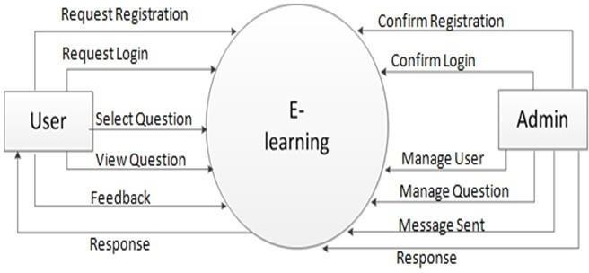

###### Fig 3.1

0 Level DFD for User

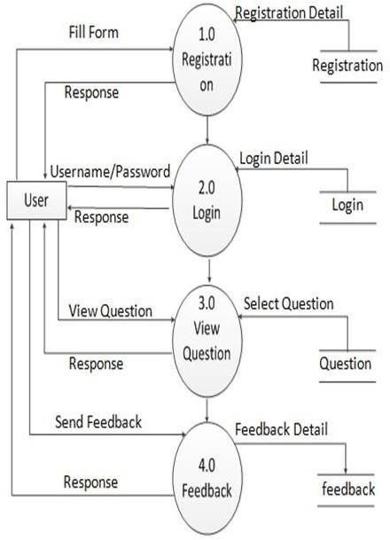

###### Fig 3.2

###### Design selection

Design selection for an e-learning website involves choosing the most suitable design based on the project's requirements and constraints. Here are some factors to consider when selecting a design for an e-learning website:

**User Experience:** The design of the e-learning website should prioritize the user experience. This includes ease of navigation, intuitive interface, clear and concise content, and effective use of multimedia.

**Branding:** The design of the e-learning website should reflect the branding of the educational institution or organization. This includes the use of appropriate colors, typography, and visual elements.

**Responsiveness:** The design of the e-learning website should be responsive, meaning it can adapt to different screen sizes and devices. This ensures that learners can access the website and its content on any device, including smartphones and tablets.

**Accessibility:** The design of the e-learning website should be accessible to all learners, including those with physical or cognitive disabilities. This includes features such as alternative text for images, closed captions, and keyboard accessibility.

**Customizability:** The design of the e-learning website should allow for customization to meet the specific needs of the educational institution or organization. This includes the ability to add or remove features and the flexibility to adjust the layout and design to accommodate different types of content.

**Technical Considerations:** The design of the e-learning website should consider technical factors such as the available technology stack, compatibility with different browsers and devices, and the level of security required.

Once the above factors have been considered, the selection of a design for an e-learning website can begin. This may involve researching and evaluating existing templates or working with a web designer to create a custom design that meets the project's specific needs and requirements. The chosen design should align with the project's goals, target audience, and branding while also prioritizing the user experience and accessibility.

When it comes to selecting a design for an e-learning website, there are several factors to consider. Here are some design considerations and options to help guide your decision:

User experience is crucial in e-learning design. The design should be intuitive, easy to navigate, and visually appealing. Consider a clean and organized layout with clear navigation menus and logical information hierarchy. Pay attention to typography, colour schemes, and the use of multimedia elements to enhance engagement and readability.

With the increasing use of mobile devices, it's important to choose a design that is responsive and adapts to different screen sizes. This ensures that learners can access the e-learning website and its content seamlessly from desktops, laptops, tablets, and smartphones.

Align the design of the e-learning website with your organization's branding and visual identity. Use consistent colours, fonts, and imagery that reflect your brand. This helps to establish a cohesive and recognizable presence, fostering trust and familiarity among learners.

Design your e-learning website with accessibility in mind. Ensure that the design meets accessibility standards, such as providing alternative text for images, using proper heading structures, and considering colour contrast for readability. This makes it possible for people with impairments to access the website's information and use it efficiently.

Consider how the design presents different types of content, such as text, images, videos, and interactive elements. Use a layout that optimizes the display of multimedia content and balances text with visuals. Incorporate interactive features, such as quizzes or simulations, in a way that enhances the learning experience.

If you are using an LMS platform, choose a design that seamlessly integrates with the LMS interface. This ensures consistency in the user experience and minimizes any potential disruption when transitioning between the website and the LMS.

Customization Options: Look for design options that allow for customization to suit your specific needs. This includes the ability to modify colours, fonts, layouts, and add your organization's logo or graphics.

Usability Testing: Consider conducting usability testing with a sample of your target audience to gather feedback on the design. This will help identify any usability issues or areas for improvement, ensuring that the design meets the needs and expectations of your learners.

###### Implementation plan/methodology

* + - The implementation plan/methodology of e-learning involves several key steps to ensure its success.
    - The first step is to identify the learning objectives of the e-learning program, which will help to determine what content needs to be created and how it should be structured. Once the content is developed, a suitable platform needs to be selected for delivering the e-learning program. This platform should be user-friendly, intuitive, and able to support different types of content such as videos, texts, and interactive exercises. The user experience (UX) should also be taken into consideration as this can greatly affect how learners engage with the content.
    - Before launching the e-learning program, it is important to test it thoroughly to ensure that it is effective and engaging. This can involve testing it with a small group of users and making any necessary refinements based on their feedback. Once the program is ready to launch, it should be promoted to the target audience using various marketing techniques such as email marketing, social media promotion, or advertising.
    - After launching the e-learning program, it is important to continually evaluate its effectiveness and make updates as needed. This could include adding new content, making changes to the UX, or updating the platform itself. It is important to remember that e-learning is an ongoing process, and it should be continually iterated and improved over time. By following this methodology, organizations can successfully implement e-learning programs that help their employees learn new skills and stay up-to-date with industry trends
    - Define learning objectives: The first step is to identify the goals and learning objectives of the e- learning program. This will help you determine what content needs to be created, and how it should be structured.
    - **Develop content:** Next, you'll need to develop the content for the e-learning program. This might include creating videos, writing text-based lessons, or developing interactive exercises.
    - **Choose a platform:** Once you have your content, you'll need to choose a platform to deliver it on. There are many different e-learning platforms available, each with its own features and benefits.
    - **Design the user experience:** The user experience (UX) is an important aspect of e-learning, as it can greatly affect how learners engage with the content. Consider things like the layout, navigation, and overall design of the e-learning program.
    - **Test and refine:** Before launching the e-learning program, it's important to test it thoroughly to ensure that it is effective and engaging. Make any necessary refinements based on feedback from test users.

**CHAPTER 4.**

**RESULT ANALYSIS AND VALIDATION**

###### Implementation of the solution

In this chapter, we present the results and validation of the E-learning website. The website was developed to provide a platform for learners to get an effective learning source.

This section outlines the outcomes of the project, including the achievement of project objectives and the validation of the website’s functionality and usability.

The implementation of E-learning website involves several key steps to ensure the successful development and deployment of the platform. This subchapter provides an overview of the implementation process, including the technologies used, development stages, and integration of essential features.

###### Technology selection:

The choice of appropriate technologies was crucial to develop a robust and scalable E-learning website. After careful consideration, the following technologies were selected:

* + - 1. **Front-End Development :** HTML5, CSS3, AND JavaScript were utilized for the website’s front- end development. These technologies provide a solid foundation for creating an interactive and visual appealing user interface.

Front-end development for e-learning websites is a critical aspect of creating a user-friendly and engaging learning experience. It is essential to ensure that the e-learning website is responsive, meaning it adapts and displays properly on various devices and screen sizes, including desktops, laptops, tablets, and smartphones. This ensures that learners can access and navigate the website seamlessly from any device, providing a consistent user experience.

The user interface (UI) of the e-learning website should be visually appealing and engaging. Thoughtful use of colors, typography, and multimedia elements can create an inviting and immersive learning environment. Utilize images, videos, and interactive elements to enhance content presentation and maintain learner engagement.

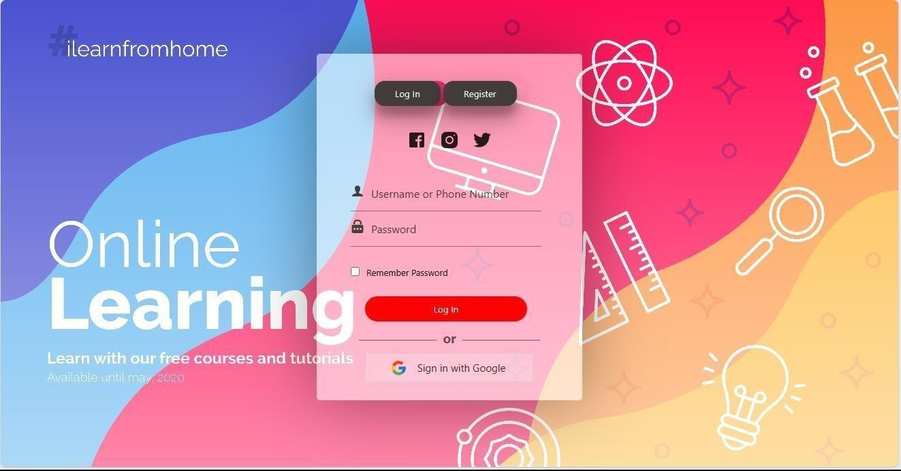

###### Fig 4.1

###### Fig 4.2

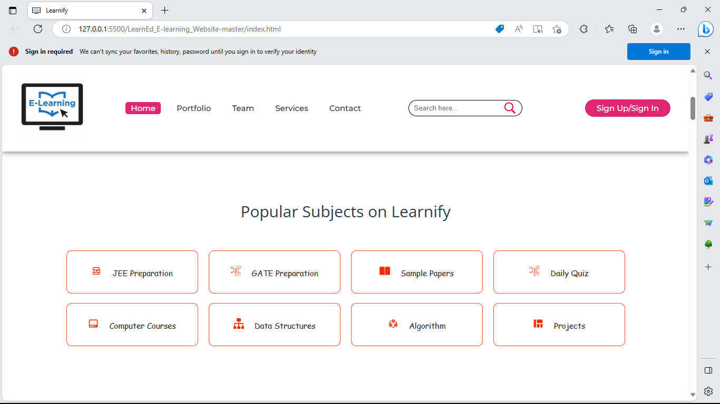

###### Fig 4.3

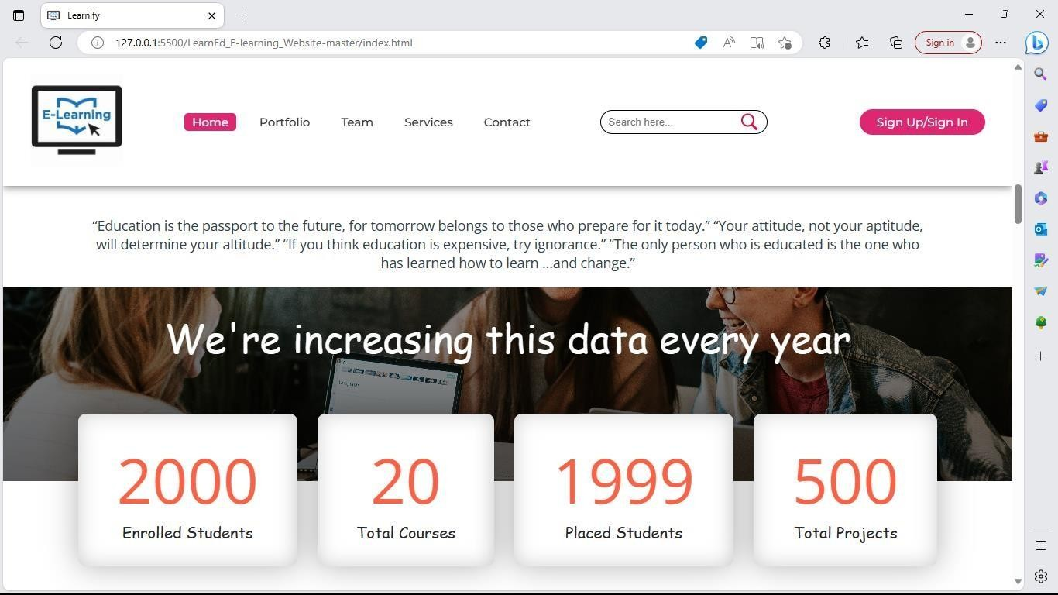

###### Fig 4.4

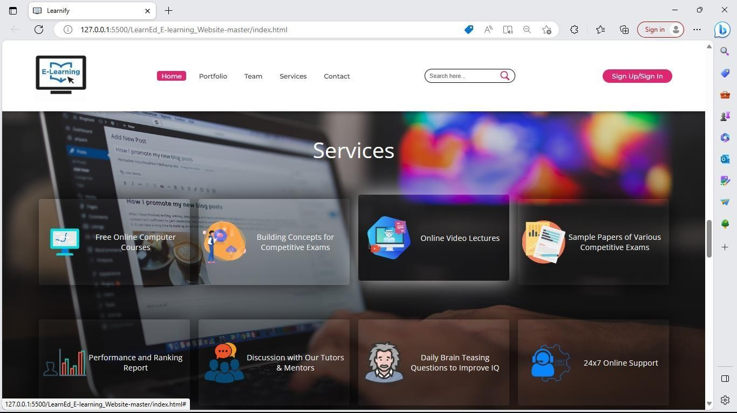

###### Fig 4.5

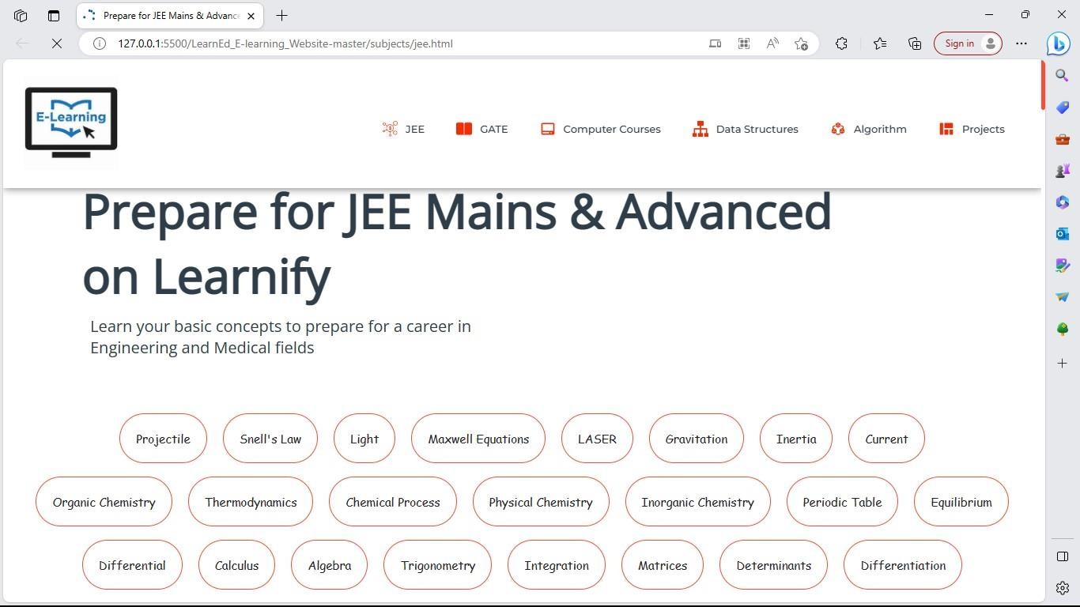

###### Fig 4.6

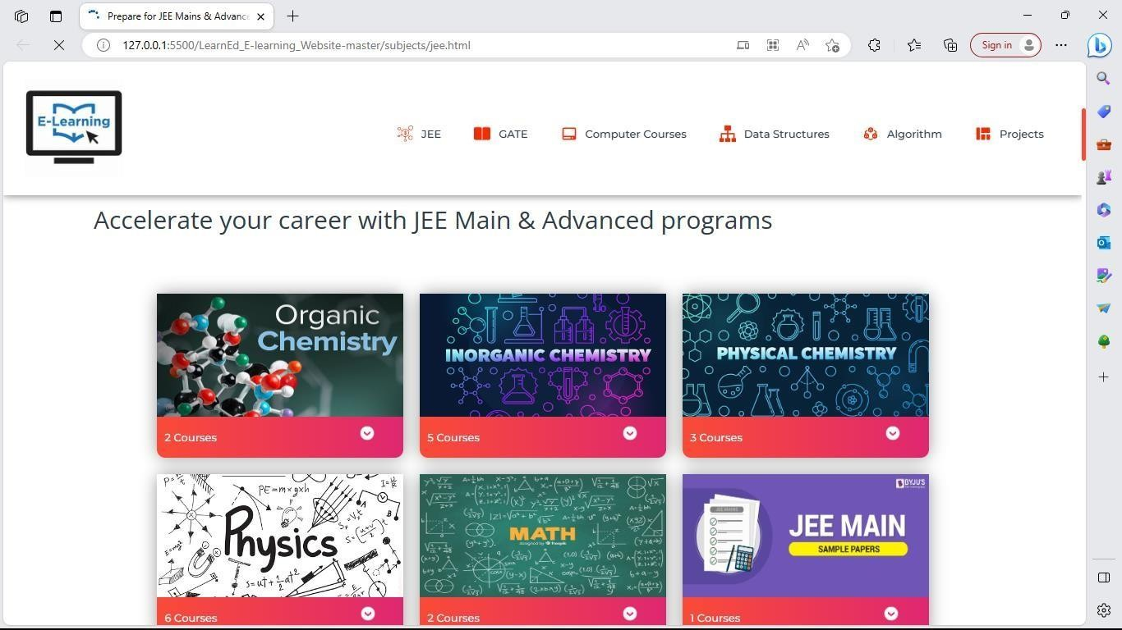

###### Fig 4.7

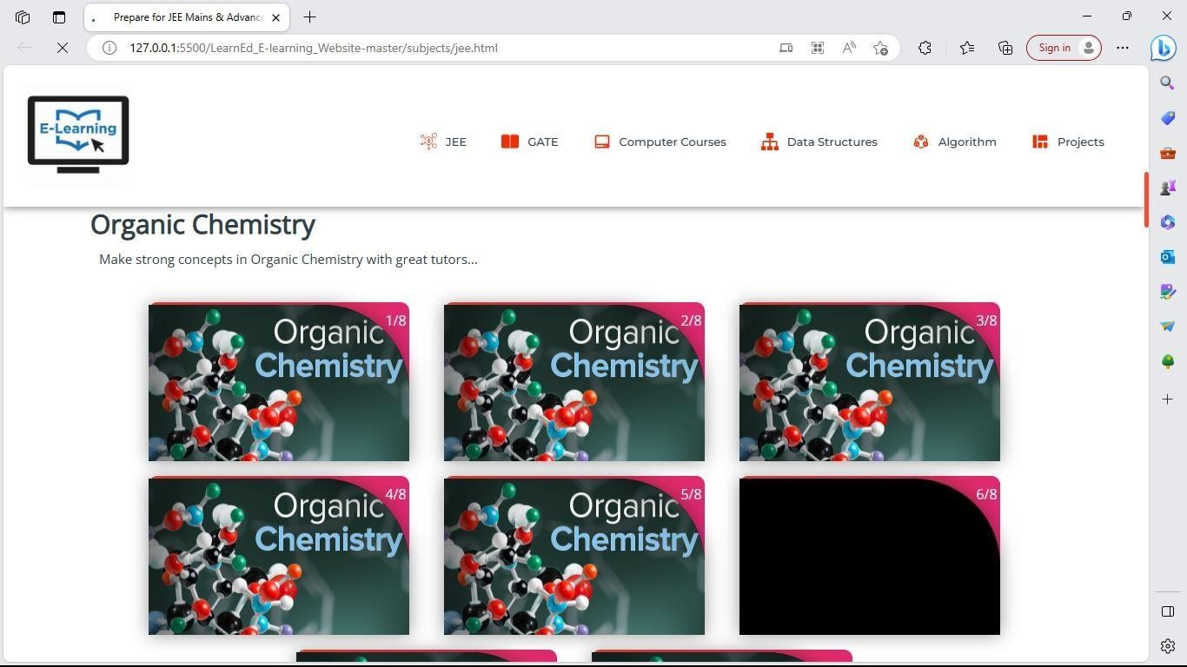

###### Fig 4.8

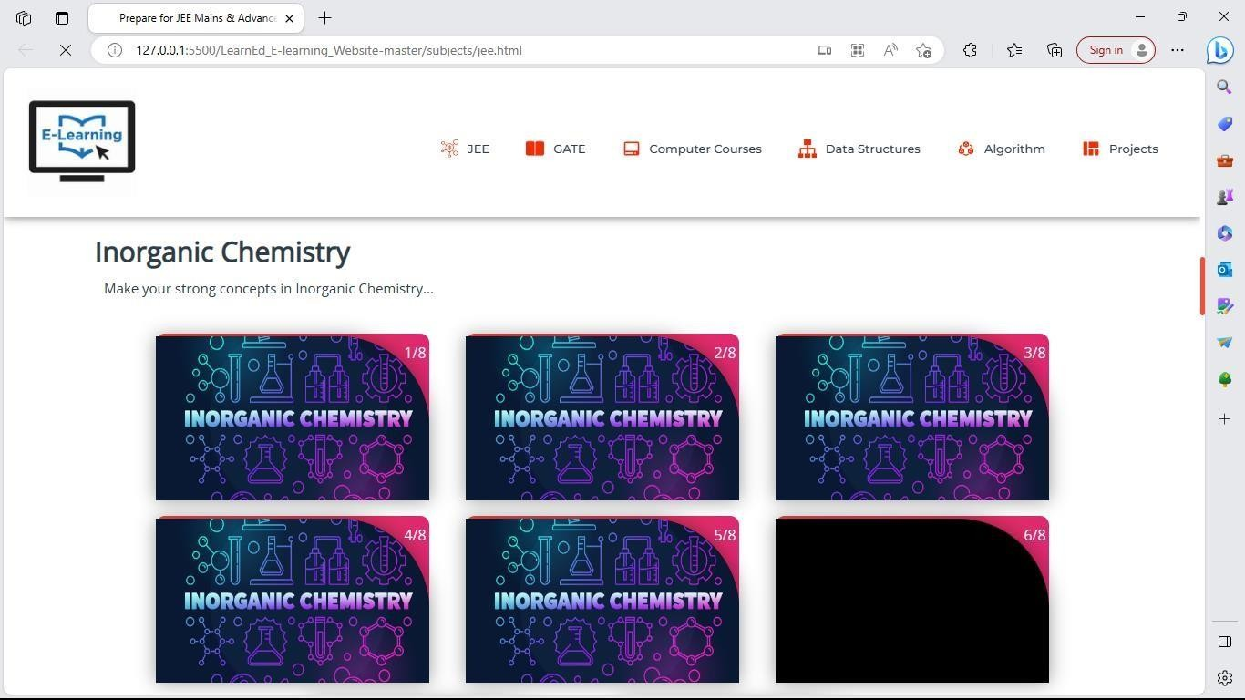

###### Fig 4.9

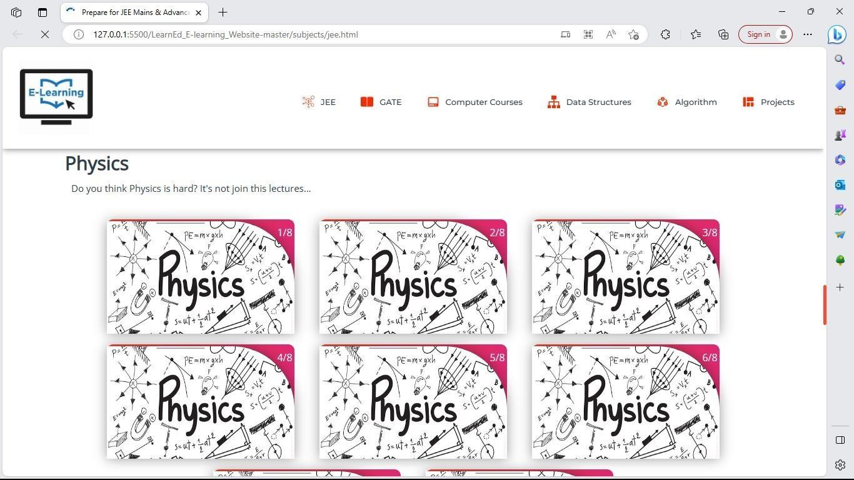

###### Fig 4.10

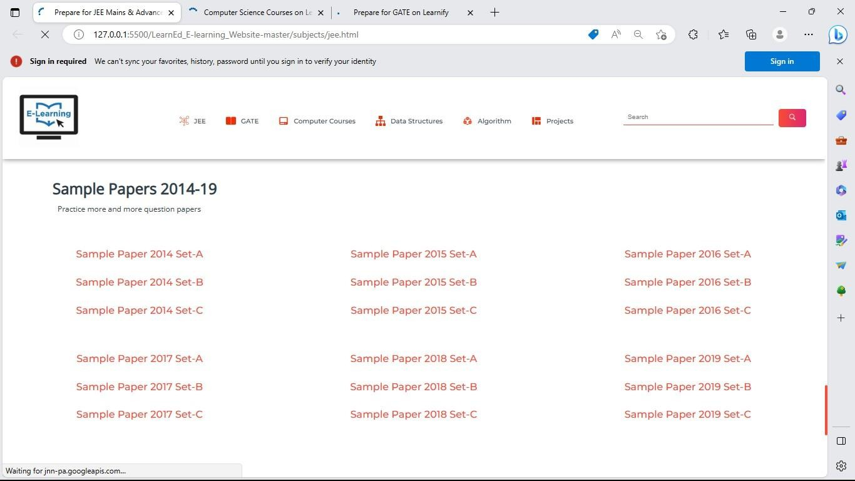

###### Fig 4.11

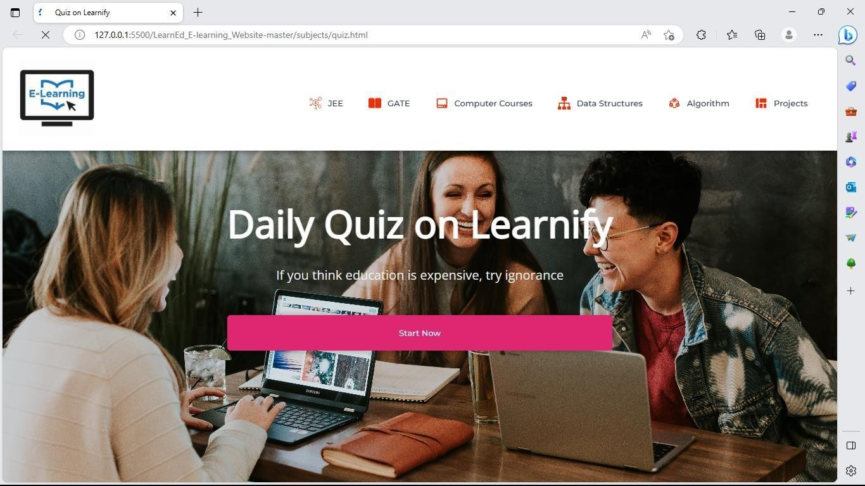

###### Fig 4.12

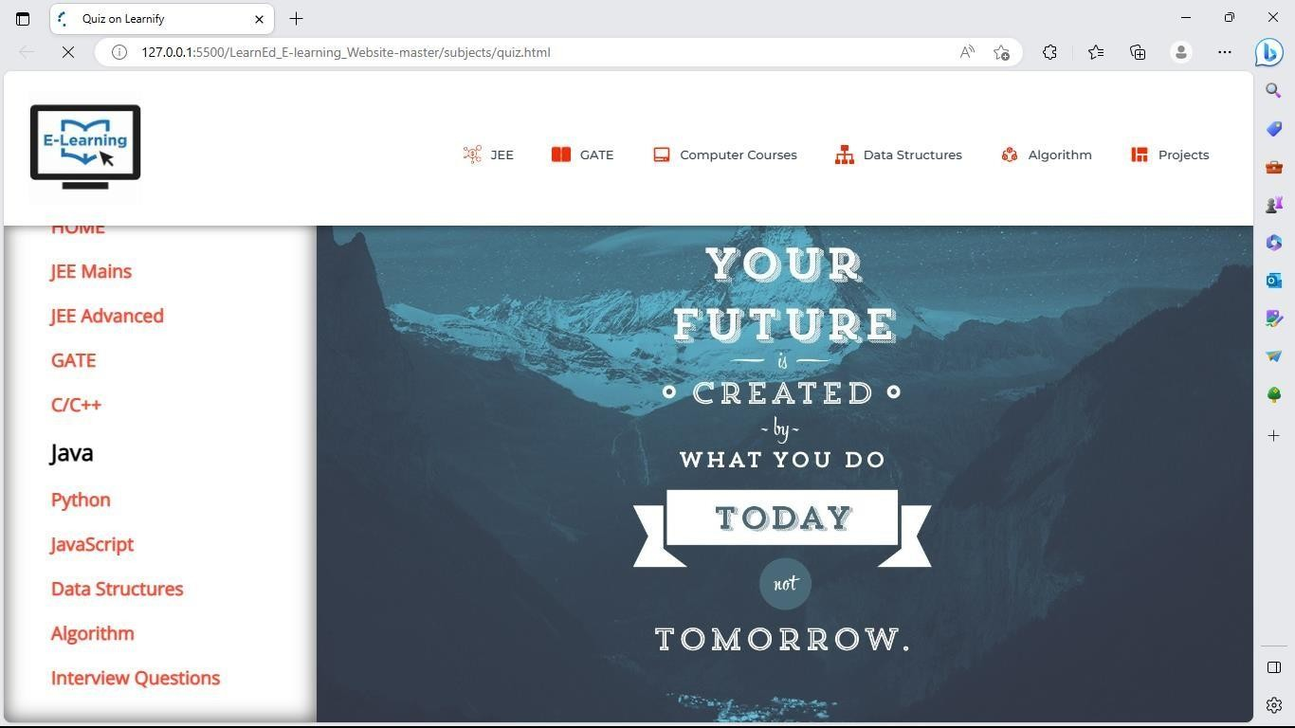

###### Fig 4.13

###### Fig 4.14

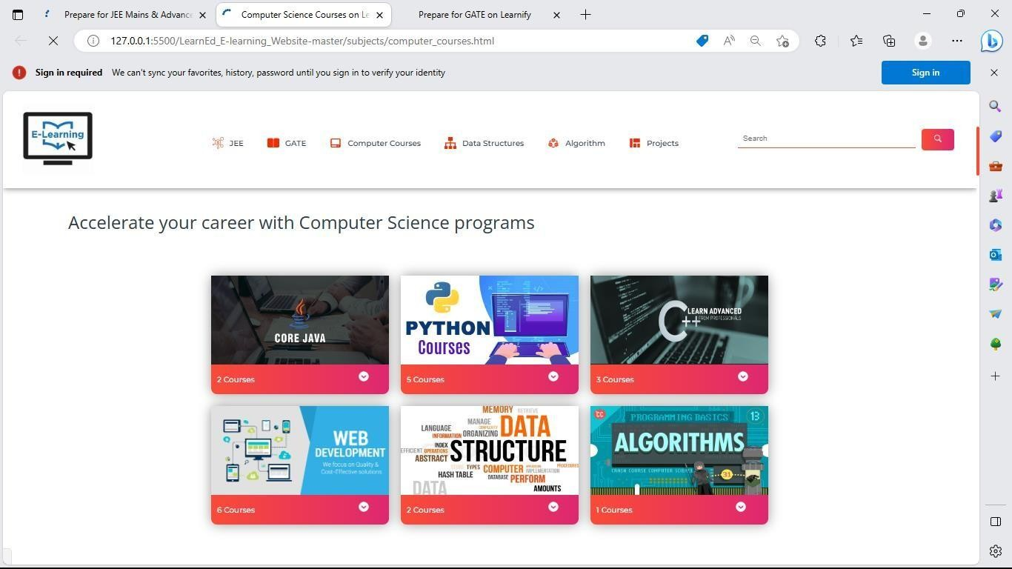

###### Fig 4.15

###### Fig 4.16

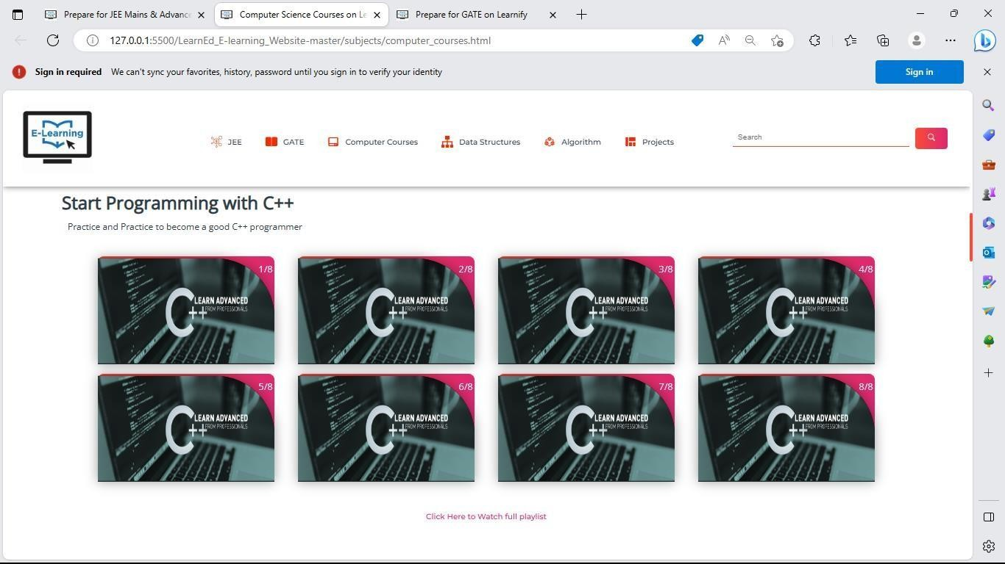

###### Fig 4.17

###### Fig 4.18

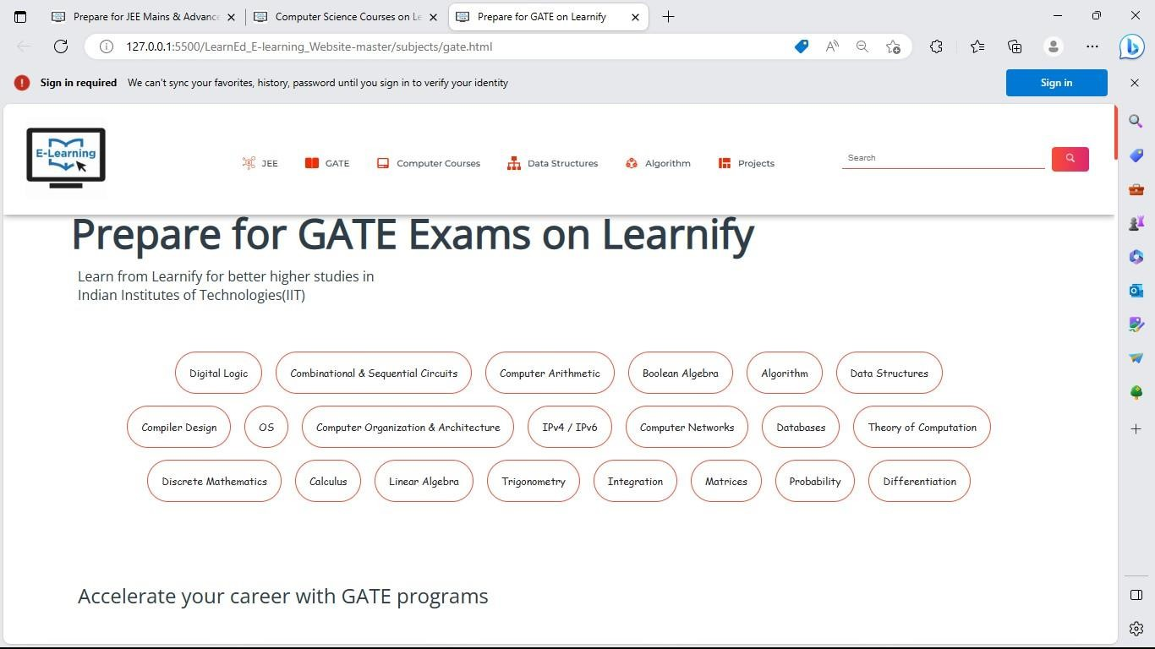

###### Fig 4.19

###### Fig 4.20

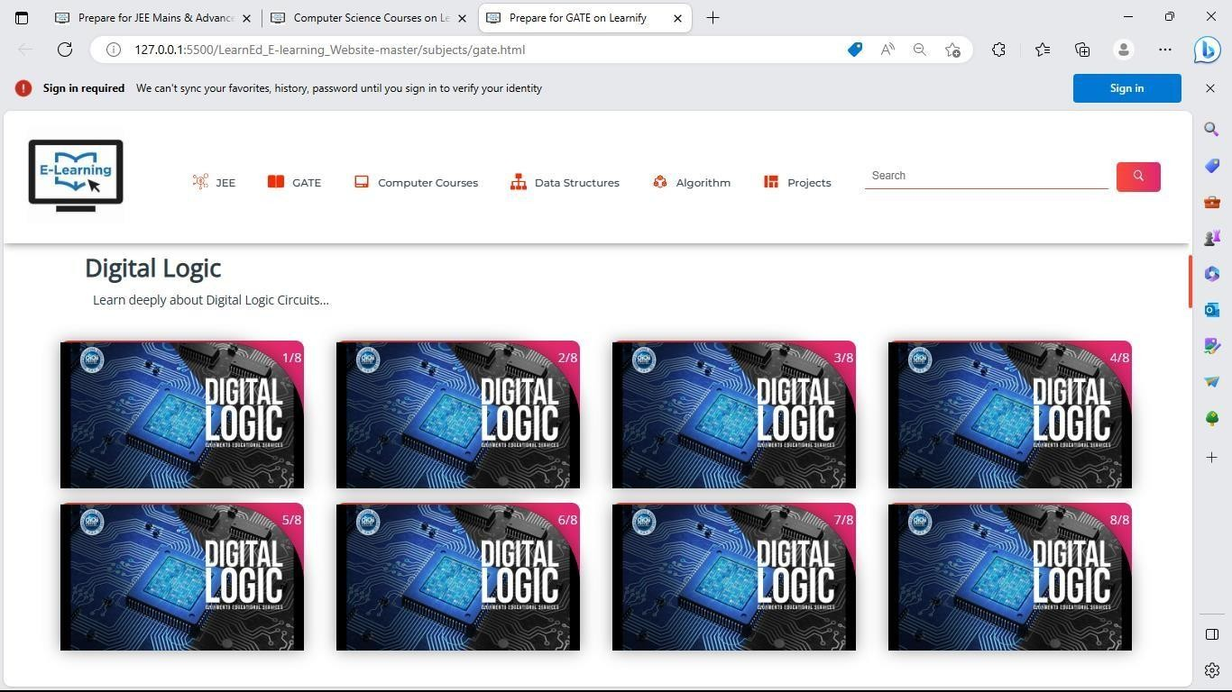

###### Fig 4.21

###### Fig 4.22

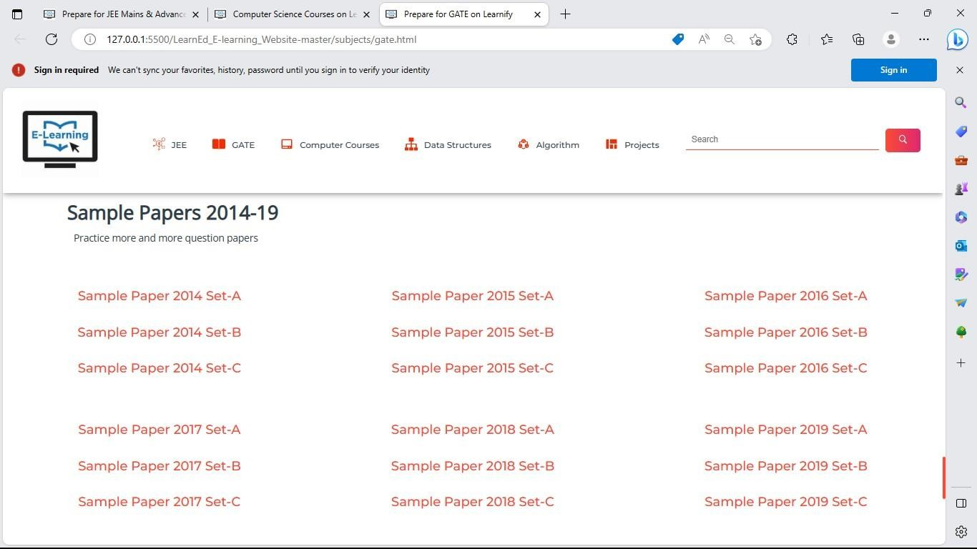

###### Fig 4.23

This is the Front-End of E-learning implementing using HTML5, CSS3, and JavaScript where user can have attractive interaction with website rather than getting some random message about events on messaging apps.

**1. Back-End development:** The website’s back-end was built using a combination of technologies, including Node Js server-side scripting, Express Js for creating different routes, and MongoDb database to store event and user information. This stack ensured efficient data management and high performance capabilities.

###### Development stages:

The implementation of the E-learning website involved several development stages including:

1. **Requirement Analysis:** Detailed requirements were gathered from stakeholders, including E- learners and potential attendees. These requirements served as the foundation for defining the website’s features and functionality.
2. **User Interface Design:** A team of UI/UX designers created wireframes and mockups to visualize the website’s layout, navigation, and overall design.
3. **Front-End Development:** The front-end development team translated the design mockups into HTML, CSS, and JavaScript code. They focused on creating an intuitive and responsive user interface that would provide a seamless experience across different devices and screen sizes.
4. **Back-End Development:** The back-end development team implemented the websites functionality using NodeJS. They built the E-learning system, user authentication.
5. **Testing and Quality Assurance:** Rigorous testing was conducted at various stages of development to identify and resolve any bugs or performance issues. This include unit testing, integration testing, and user acceptance testing to ensure the website meet the specified requirements.

**CHAPTER 5.**

**CONCLUSION AND FUTURE SCOPE**

###### Conclusion

In conclusion, e-learning websites have become increasingly popular and have shown great potential in delivering education and training in a flexible and accessible manner. Through the analysis of E-learning results, it can be determined that these websites have the ability to effectively facilitate learning outcomes, improve learner performance, increase engagement and participation, and enhance learner satisfaction. Furthermore, e-learning platforms offer the advantages of scalability, cost effectiveness, and the ability to track and measure learner progress.

Firstly, e-learning websites provide flexibility and convenience. Learners can access educational resources anytime, anywhere, and at their own pace. This flexibility allows individuals to balance their education with other responsibilities, such as work or family commitments.

Secondly, e-learning websites offer a wide range of courses and subjects. Whether someone is interested in academic subjects, professional skills, or personal development, there is an abundance of options available online. This vast selection allows learners to pursue their specific interests and tailor their education to their needs and goals.

Furthermore, e-learning websites often utilize interactive and engaging learning methods. These platforms incorporate multimedia elements such as videos, quizzes, and interactive exercises, making the learning process more enjoyable and effective. Learners can also engage in discussions and collaborate with peers from around the world, fostering a sense of community and expanding their perspectives.

Additionally, e-learning websites provide access to expert instructors and industry professionals. Learners can benefit from the expertise and knowledge of renowned educators, often at a fraction of the cost of traditional education. This democratization of education enables individuals from all walks of life to access high-quality learning resources and opportunities.

Lastly, e-learning websites offer lifelong learning possibilities. With the rapid advancements in technology and knowledge, continuous learning has become crucial for personal and professional growth. E-learning platforms provide the means to continually update skills and knowledge, ensuring individuals stay relevant in today's fast-paced world.

However, it is important to note that the success of an e-learning website is dependent on several factors, including the quality of the content, the usability of the platform, the availability of resources and support, and the overall design and user experience. Continuous improvement and adaptation based on feedback and evaluation are essential for the ongoing success of an e-learning website.

###### Future Scope

To personalize the learning experiences, e-learning platforms will increasingly use ai technologies. In order to offer specialised recommendations, adaptive evaluations, and personalised content, AI algorithms will analyse each user’s learning patters, preferences, and performance. With this strategy, learning outcomes will be maximised and students will be able to advance at their own rate.

E-learning websites will leverage VR and AR technologies to create immersive learning environments. Learners will be able to engage in realistic simulations, virtual labs, and interactive experiences, enhancing their understanding and practical skills. This technology will revolutionize fields such as medical training, engineering, and vocational education.

The demand for bite-sized, on-the-go learning content will continue to grow. E-learning websites will offer microlearning modules that provide concise and focused lessons, accessible on mobile devices. Mobile apps will become more sophisticated, providing offline access, gamification, and social learning features.

E-learning platforms will emphasize collaborative learning through virtual classrooms, discussion forums, and project-based activities. Learners will have the opportunity to connect with peers, share

knowledge, and engage in group projects, fostering a sense of community and enhancing the social aspect of online learning.

E-learning websites will increasingly cater to the demand for practical skills and career advancement. They will offer specialized courses and certifications aligned with industry needs, addressing emerging job markets and technological advancements. Professional development and upskilling will become a major focus, helping individuals stay competitive in the evolving job market.

Moving forward, there are several areas of focus for the future development and enhancement of E- learning websites:

**Personalization:** Implementing personalized learning experiences by leveraging technologies such as adaptive learning algorithms, machine learning, and artificial intelligence. This can help tailor the content and delivery to individual learner needs, preferences, and learning styles.

**Interactivity and Collaboration:** Enhancing interactivity and fostering collaboration among learners through the integration of discussion forums, virtual classrooms, and interactive activities. This promotes engagement, peer learning, and knowledge sharing.

**Mobile Learning:** Optimizing e-learning platforms for mobile devices, considering the increasing use of smartphones and tablets for accessing online content. This allows learners to access educational materials anytime and anywhere, facilitating continuous learning.

**Gamification and Simulations:** Incorporating gamification elements, such as points, badges, and leaderboards, to make the learning experience more enjoyable and motivating. Additionally, integrating simulations and virtual reality can provide immersive and practical learning experiences.

**Analytics and Learning Analytics**: Leveraging data and analytics to gain insights into learner behavior, performance patterns, and learning gaps. This can help instructors and administrators make data-driven decisions, customize learning pathways, and provide targeted interventions.

**Accessibility and Inclusivity:** Ensuring that e-learning websites are accessible to learners with disabilities and accommodating diverse learning needs. This involves adhering to accessibility standards, providing alternative formats for content, and implementing assistive technologies.

**Continuous Evaluation and Improvement:** Establishing a feedback loop with learners and stakeholders to gather insights, assess the effectiveness of the e-learning website, and make iterative improvements. This can be done through surveys, focus groups, user testing, and data analysis.

In summary, the future of e-learning websites is dynamic and full of potential. With advancements in AI, VR/AR, mobile technology, and data analytics, these platforms will continue to enhance the learning process, promote personalized education, and bridge the gap between traditional and online learning. The future scope of e-learning websites lies in their ability to provide engaging, accessible, and effective educational experiences for learners of all backgrounds and ages.(11)

**References**

* + 1. **<https://scholar.google.com/citations?hl=en&user=dpYhOkMAhAJ>**
    2. **.<https://scholar.google.com/citations?hl=en&user=0SHWBuoAAAAJ>**
    3. **<https://github.com/gazpachu>**
    4. Angeli, C. (2005) ‘Transforming a teacher education method course through technology: Effects on preservice teachers’ technology competency’, Computers & Education, vol. 45, no. 4, pp. 383–398.
    5. Armatas, C., Holt, D. and Rice, M. (2003) 'Impacts of an online-supported, resource-based learning environment: Does one size fit all?' Distance Education, vol. 24, no. 2, pp. 141–158.
    6. Haverila, M. (2010) 'Factors related to perceived learning outcomes in e-Learning', International Journal of Knowledge and Learning, vol. 6, no. 4, pp. 308–328.
    7. Maloney, S., Haas, R., Keating, J. L., Molloy, E., Jolly, B., Sims, J., … Haines, T. (2011) 'Effectiveness of web-based versus face-to-face delivery of education in prescription of falls-prevention exercise to health professionals: Randomized trial', Journal of Medical Internet Research, vol. 13, no. 4.
    8. Means, B., Toyama, Y., Murphy, R. F. and Baki, M. (2013) 'The effectiveness of online and blended learning: A meta-analysis of the empirical literature', Teachers College Record, vol. 115, no. 3, p. 1.
    9. Noesgaard, S. S. (2014) 'Supporting transfer of learning: Practice-based considerations on the applicability of transfer literature in online design', in the conference proceedings from Designs for Learning, Stockholm May 2014, pp. 1–5.
    10. A. Gunasekaran, R. D. Mcneil, and D. Shaul, “E-learning: Research and applications,” *Industrial and Commercial Training*, vol. 34, no. 2, pp. 44–53, Apr. 2002, doi: 10.1108/00197850210417528.
    11. S. V. Thakker, J. Parab, and S. Kaisare, “Systematic research of e-learning platforms for solving challenges faced by Indian engineering students,” *Asian Association of Open Universities Journal*, vol. 16, no. 1, pp. 1–19, May 2021, doi: 10.1108/AAOUJ-09-2020-0078.